Ex No: 12 DESIGN A WEBSITE FOR ONLINE SHOPPING THAT GATHERS INFORMATION AS PART OF AN ONLINE PRODUCT ORDERING SYSTEM USING WORDPRESS DEVELOPMENT ENVIRONMENT

1.Score the Perfect Domain Name
Your domain name is your website’s unique address on the internet (e.g.,www.example.com).Choose something short, memorable, and relevant to your brandor business.
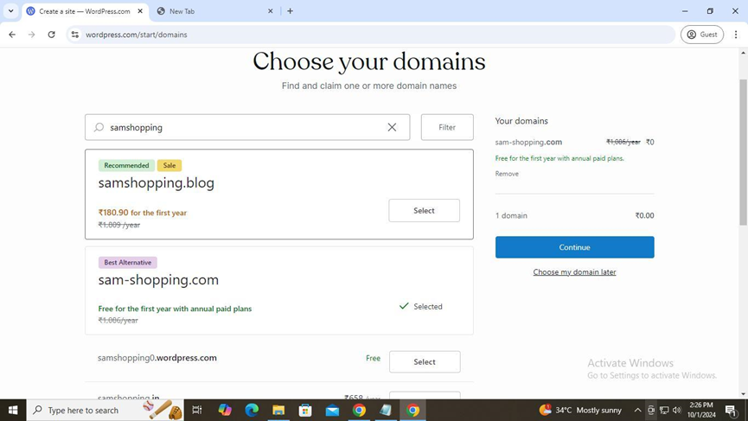

2. Sign Up to WordPress
Visit WordPress's official site and create an account. Opt for WordPress.org for better control and customization options, especially for eCommerce websites.

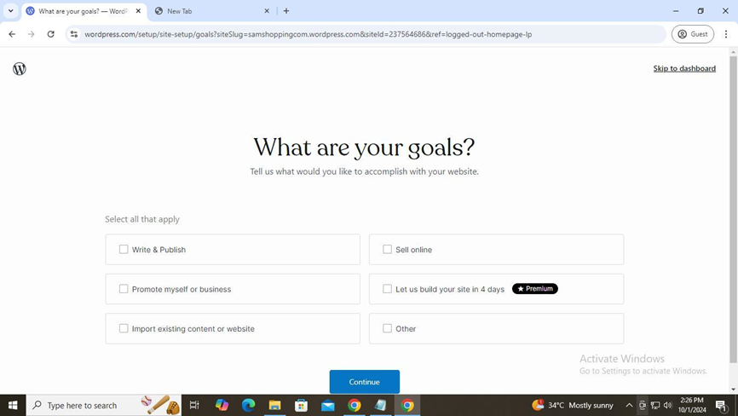

3. Give Your Store a Name and Tagline
Name your store and add a short tagline that summarizes your brand’s mission or product offerings, which will appear on your site’s homepage.

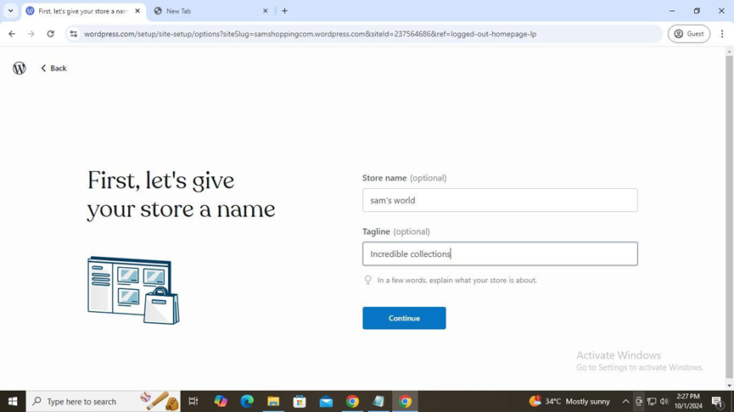

4. Choose a Theme
Select a WordPress theme that matches your brand's style. Themes control your site's design, but you can always customize it later to better fit your needs.

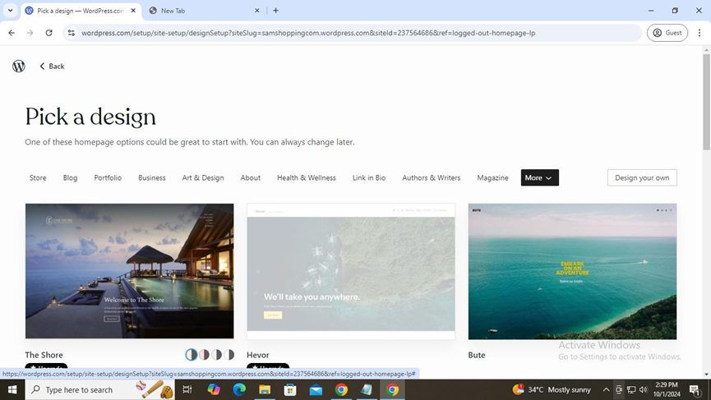

5. Add Products
Use an eCommerce plugin like WooCommerce to add products, descriptions, and images to your site. Organize items into categories to improve user navigation.

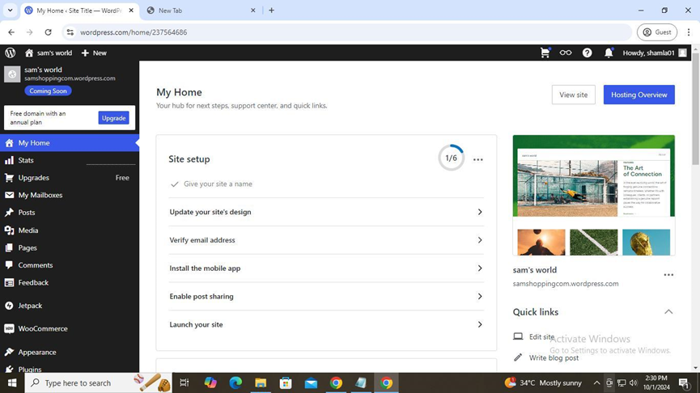

6. Add More Pages for Different Uses
Create additional pages like "About Us," "Contact Us," and legal pages such as "Privacy Policy" to provide customers with essential information and support.

7. Make Your Site Public
Once your site is fully set up and tested, set it to public, allowing customers to visit and make purchases from your online store.
